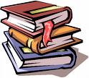
Is Reading for you?
Designed by: A.M.

1. Do you like to read?
A) Yes B) No C) Sometimes

2. What genre of books do you like to read?

A) Mystery B) Romance C) Adventure
D) Other: ________________________

3. Does reading relax you? Yes No Explain:

4. What’s your favourite book? ______________________________

5. How many books do you read a month? (Please circle)
0 1 2 3 4 5 6 Other:______

6. Who’s your favourite author? ____________________________

