Scatter Plots - day 2 (section 1.8 pg61-pg65)
Trend?
As x increases y increases

Correlation?
strong positive correlation
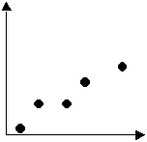

examples
- As the person’s age (years) increases their height (feet) increases
- As the practice time (hours) increases their shooting percentage (%) increases
- the greater the study time the greater the test mark result

percentage = the number of goals divided by the totals shots on goal

ovechkin
63goals/436shots on goal = 14.40%

according the the nhl stats as of April 3, 2008
the trend we notice is…
as shots on goal increase, the total points increases,
however, this is a weak positive correlation.

Extra Practice
pg64 #7, 9, 10 (graph 4 separate scatter plots)

