MPM 1D 5.8/5.9 Finding the Point of Intersection: Applications

Example: Pg. 320 #10

Ralph works part-time for a bike repair shop. He earns $2 for each tire he installs and $5 for each gear mechanism he assembles. Last week he completed 40 jobs and earned $110.

a) Write an equation that represents the total number of jobs Ralph completed
last week.
b) Write an equation that represents his week’s earnings.
c) Graph the coordinates on the same coordinate grid.
d) Describe the significance of the point at which the lines intersect. What do the coordinates tell you about the situation?
e) Express both equations in standard form.

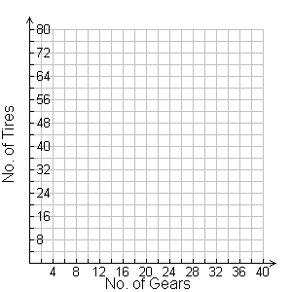
Example: Pg. 327 #8

Eve operates an apple farm. She spreads a mixture of a fertilizer called All Grow and a weed suppressant, No Weed, around her trees each autumn. She spent $800 this autumn to fill the spreader. All Grow costs $2.50/kg and No Weed costs $5.00/kg. Her spreader holds 200 kg of mixture. How much of each did she use?

